There are three candies placed randomly in storage 3. A robot should move them to the ‘packaging’ stands into respective rows and columns: column 1 – red objects, column 2 – green objects, column 3 – blue objects, row 1 – flat top candies, row 2 - flat top candies with holes, row 3 - globe-shaped candies. The task is deemed complete if each object touches only the respective stand of the ‘packaging’ and the robot stays at the zero position with the accuracy of at least 1.5 mm. Losing or lifting the candies again is not allowed during the task. The task should be complete within 120 sec.

Initial arrangement example:

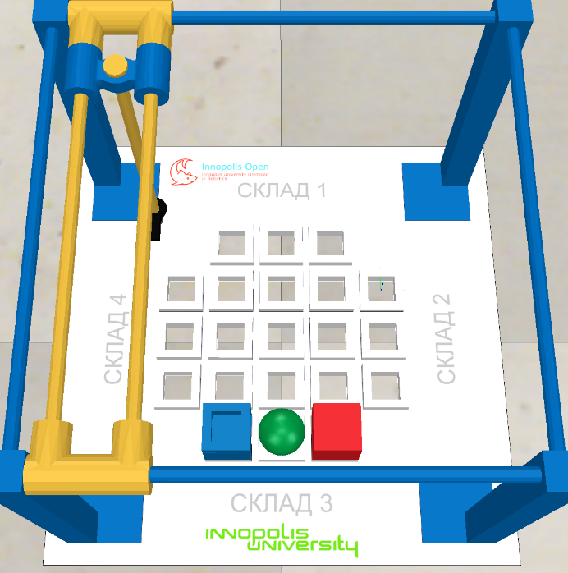

End of the attempt for the example given:

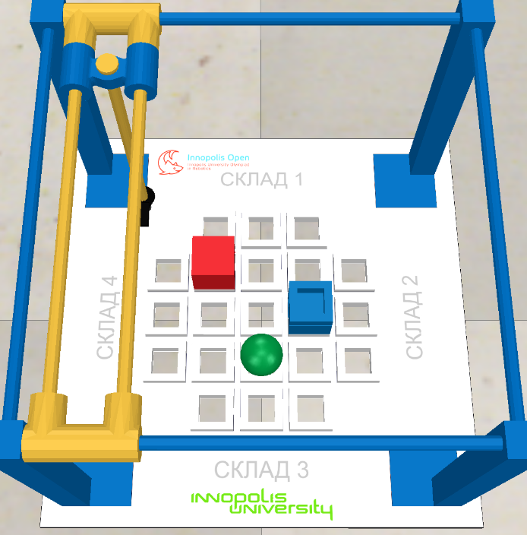

Three files with source code are accepted for answers:

- Child.lua – the source code of the program working in the asynchronous mode;

- Customization.lua - the source code of the program, working in the synchronous (step-by-step with the simulator) mode;

- ManIRS_junior.py – the source code of the robot control program in Python.

The program can be written in one of these files or in several files. The original versions of these files are located in the Programming/Lua and Programming/Python catalogues.